EC2 Stop

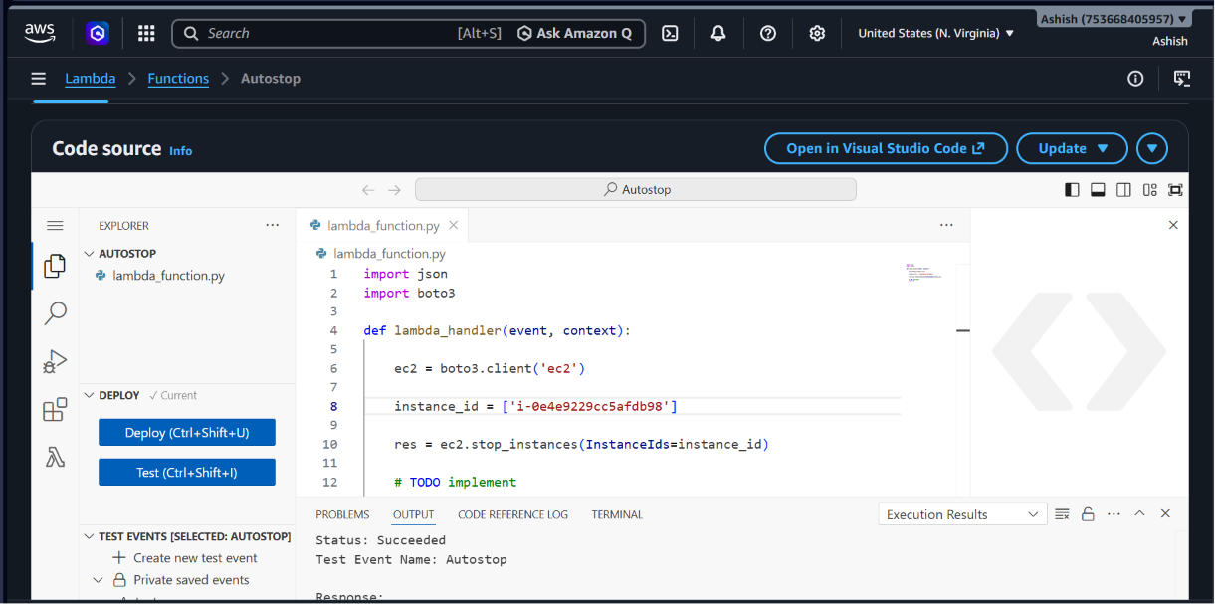

Lambda function 👍
import json
import boto3

def lambda_handler(event, context):

ec2 = boto3.client('ec2')

instance_id = ['i-0e4e9229cc5afdb98']

res = ec2.stop_instances(InstanceIds=instance_id)

# TODO implement
return 0

IAM permission given as per requirement

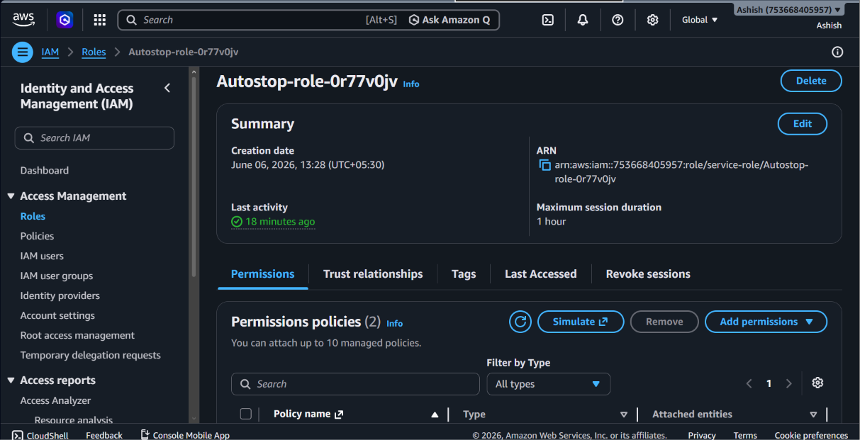

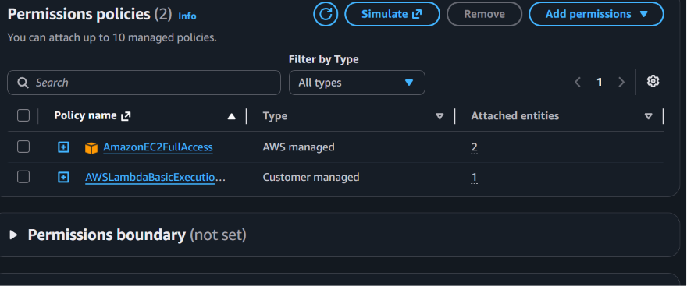

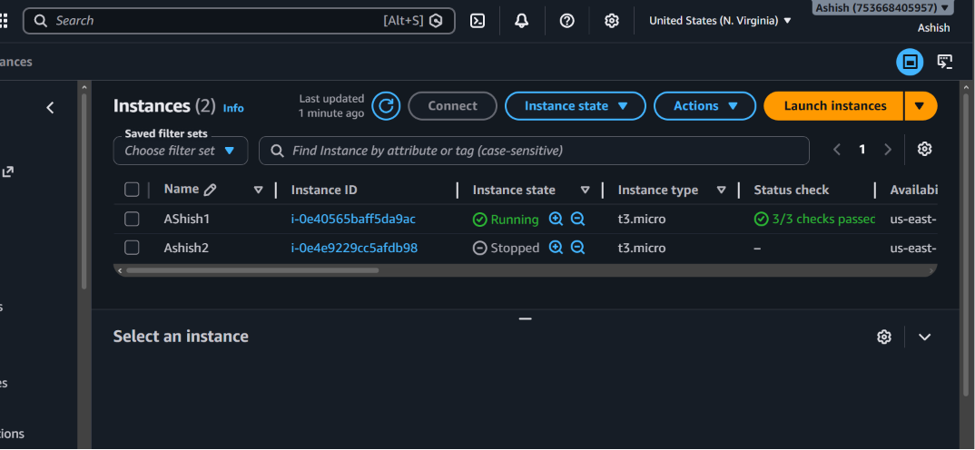

EC2 autostart

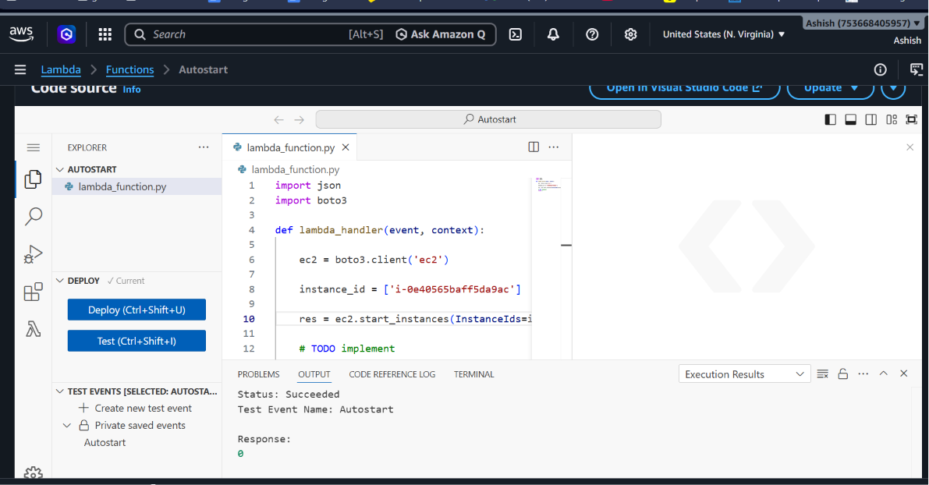

Lambda function:

import json
import boto3

def lambda_handler(event, context):

ec2 = boto3.client('ec2')

instance_id = ['i-0e40565baff5da9ac']

res = ec2.start_instances(InstanceIds=instance_id)

# TODO implement
return 0

IAM role:

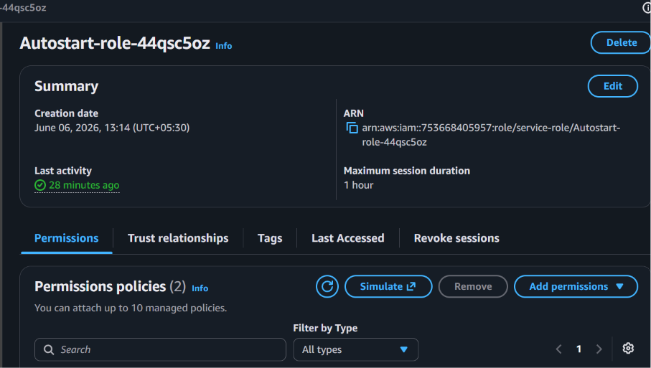

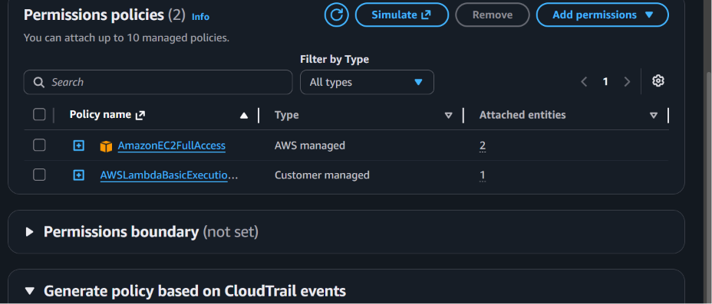



Instances:



